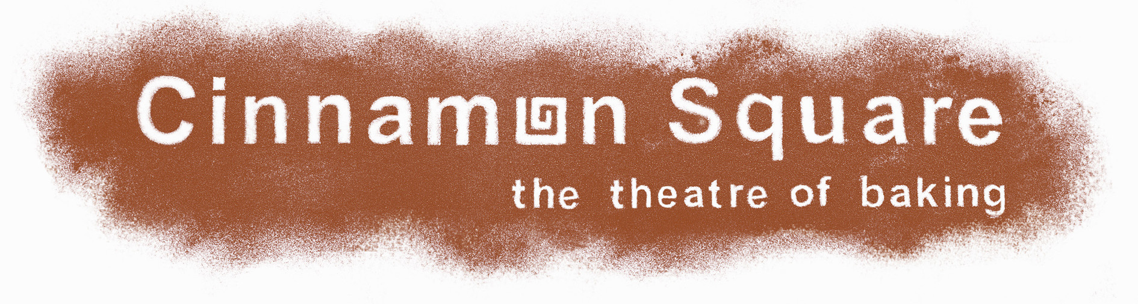

Please complete this form to apply for your free bread making session.

This initiative is open to primary schools in Watford, Croxley Green, Rickmansworth and Chorleywood and is suitable for children in years 5 and 6. We can accommodate 15 children per session and if necessary, we will run 2 sessions for each school.

The sessions will run three times per year and applying schools will be randomly selected.

Name of school: …………………………………………

Address: …………………………………………

…………………………………………

…………………………………………

Phone No: …………………………………………

Contact: …………………………………………

Please circle which term you wish to attend:

January to April April to July September to December

Please return completed form to:

Tricia Barker
Cinnamon Square
7-9 Church Street
Rickmansworth
Herts
WD3 1BX

Or email:

triciabarker@cinnamonsquare.com

Tel:

01923 778353

